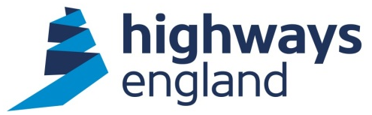  Ken Flood  Parish Clerk  Eastcote Cottage  Barston Lane  Solihull  West Midlands  B92 0JJ | Jonathan Pizzey  Senior Project Manager  M42 Junction 6 Improvement  Highways England  The Cube  199 Wharfside Street  Birmingham B1 1RN  www.highways.gov.uk/m42-j6  4th January 2018
Dear Ken Flood,

M42 JUNCTION 6 IMPROVEMENT SCHEME: PUBLIC CONSULTATION

Consultation from 9 January to 19 February 2018

Section 42 Planning Act 2008

Highways England (HE) is a government-owned company. We are responsible for the operation, maintenance and improvements to England’s Strategic Road Network (SRN). This includes delivery of the government’s Road Investment Strategy (RIS) commitments, published in 2014 by the Department for Transport.

The RIS outlines how the government plans to invest in the SRN and commits us to undertake a “comprehensive upgrade of the M42 junction 6 near Birmingham Airport, allowing better movement of traffic on and off the A45, supporting access to the airport and preparing capacity for the new HS2 station” (the Scheme).

Highways England (the Applicant) is promoting a scheme to improve M42 Junction 6.
The proposed scheme is categorised as a Nationally Significant Infrastructure Project (NSIP) under the Planning Act 2008. As such, we are required to make an application for a Development Consent Order (DCO) to the Planning Inspectorate (PINS) who will examine the application on behalf of the Secretary of State in order to obtain permission to construct the scheme.

Consultation on the Project
During the pre-application process, Highways England is required to consult with a variety of persons and organisations about the proposed application in accordance with the requirements of the 2008 Act. Your organisation has been identified as a statutory consultee for the purposes of S42 (a) of the Planning Act 2008, and this letter is the formal notice of Highways Englands planned Statutory Public Consultation event from 9 January 2018 to 19 Feb 2018.

Consultation documents
Highways England is preparing an Environmental Impact Assessment in accordance with the Infrastructure Planning (Environmental Impact Assessment) Regulations 2009; to support our future DCO application.

As part of the statutory consultation on the proposed application Highways England has prepared a Preliminary Environmental Information Report (PEIR) to help consultees understand the likely effects of the construction and operation of the scheme.

During the consultation period Highways England will be holding a number of public exhibitions at which Highways England and specialists will be available to answer any questions. The Highways England Website will host an electronic version of the exhibition material and questionnaire during the consultation period, which will include The PEIR, its technical appendices, non-technical summary, consultation brochure and other consultation material.

Your feedback on the Scheme will be considered before the Highways England finalises its application to PINS for a DCO to authorise the Scheme and will also be reported to PINS when the application is submitted. Any representations you have already made will also be reported.

The consultation starts on 9 January 2018 to 23:59 19 February 2018. Your comments would be welcome via:

Highways England Website: www.highways.gov.uk/m42-j6
Email: at M42J6@highwaysengland.gov.uk
Post: M42 Junction 6 Improvement, Highways England, The Cube, 199 Wharfside Street, Birmingham B1 1RN

Further information about the 2008 Act process and Development Consent Orders can be found on the Planning Inspectorate’s National Infrastructure Planning website: http://infrastructure.planninginspectorate.gov.uk/

If you wish to discuss this consultation, require copies of the documentation or have any other queries in connection with the Scheme please do not hesitate to contact us.
For your information I have enclosed:
- a plan of the scheme showing the alignment and red-line boundary;
- A leaflet showing the dates, times and locations of our planned Exhibitions.

Yours faithfully,
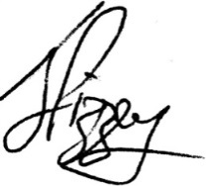
Jonathan Pizzey
Senior Project Manager - M42 Junction 6 Improvement scheme
T: 0300 123 5000

